TASK 3 REPORT
Flask Mini Web Application (Todo List App)
Submitted By
Name: J.Sneha
Internship: Python development Internship
Task: Task 3 – Flask Mini Web App

1. Objective
The objective of this project is to develop a simple Flask-based web application that demonstrates CRUD (Create, Read, Update, Delete) operations. The application allows users to manage their daily tasks through a user-friendly web interface.

2. Project Title
Todo List Web Application Using Flask

3. Technologies Used
- Python
- Flask Framework
- HTML
- CSS (Basic Styling)
- Visual Studio Code / IDLE
- Web Browser

4. Project Description
The Todo List Web Application is a simple task management system developed using the Flask framework. Users can add new tasks, view existing tasks, update task details, and delete tasks when completed. The application demonstrates the implementation of Flask routing, templates, and CRUD operations.

5. Features Implemented
Create
Users can add new tasks to the todo list.
Read
Users can view all tasks displayed on the webpage.
Update
Users can modify existing tasks using the update feature.
Delete
Users can remove completed or unwanted tasks from the list.

6. Project Structure
flask_todo_app
│
├── app.py
│
└── templates
│
└── index.html
Screenshot 1: Project Folder Structure
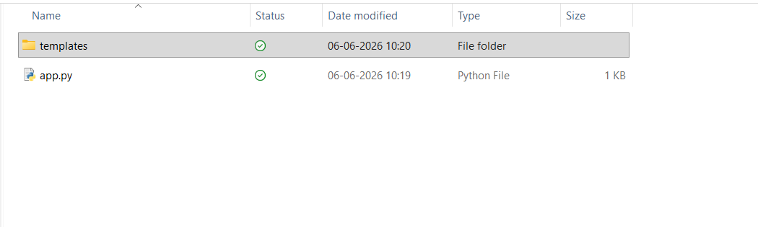

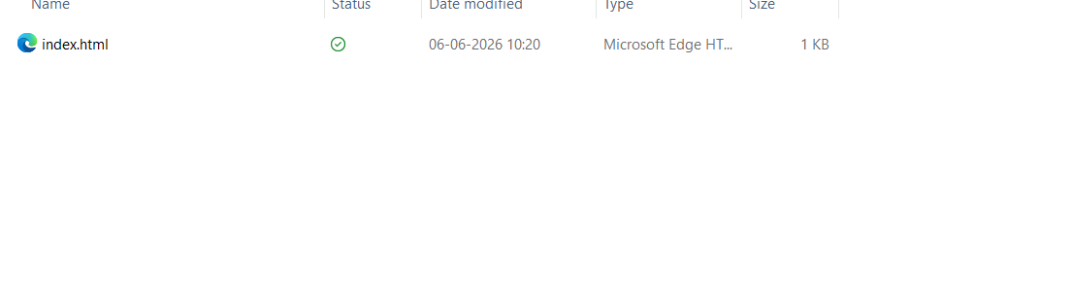

7. Source Code
Screenshot 2: app.py Code
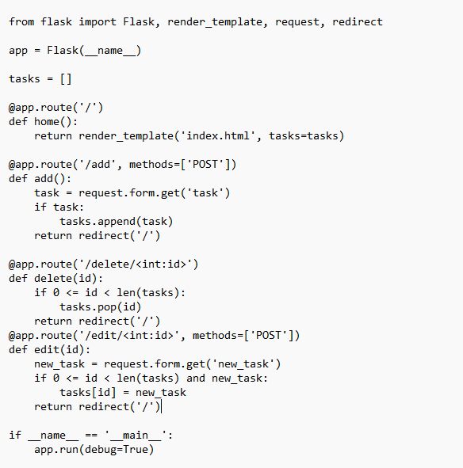

Screenshot 3: index.html Code
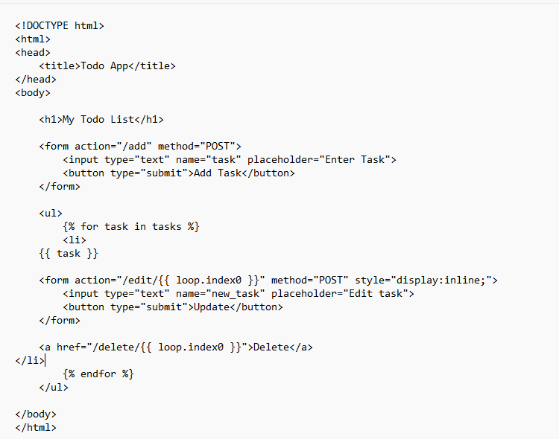

8. Project Execution
The Flask application was executed using the following command:
python app.py
The application runs on:
http://127.0.0.1:5000

Screenshot 4: Flask Application Running
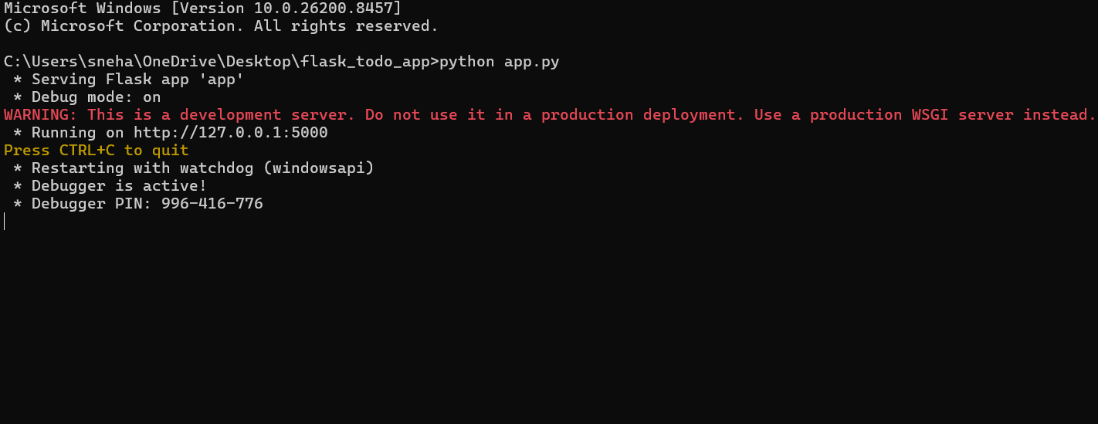

9. CRUD Operations Demonstration
Create Operation
A new task is entered and added to the todo list.
Screenshot 5: Adding a New Task
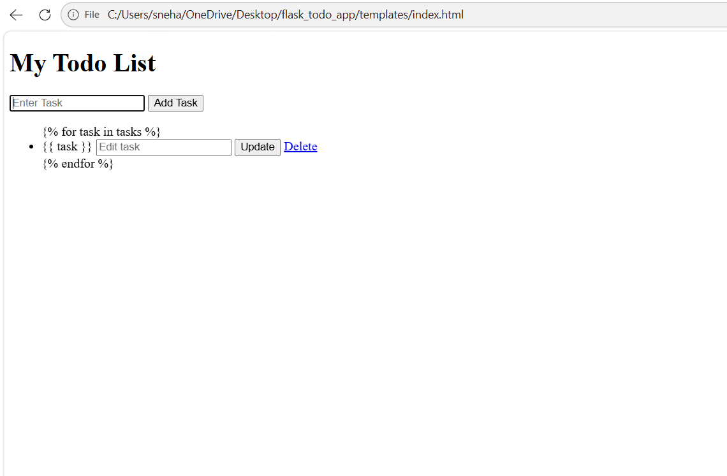

Read Operation
The added task is displayed on the webpage.
Screenshot 6: Viewing Tasks
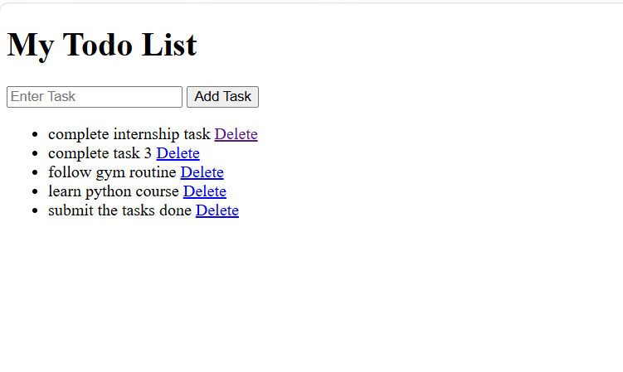
Update Operation
An existing task is modified using the update feature.
Screenshot 7: Updating a Task
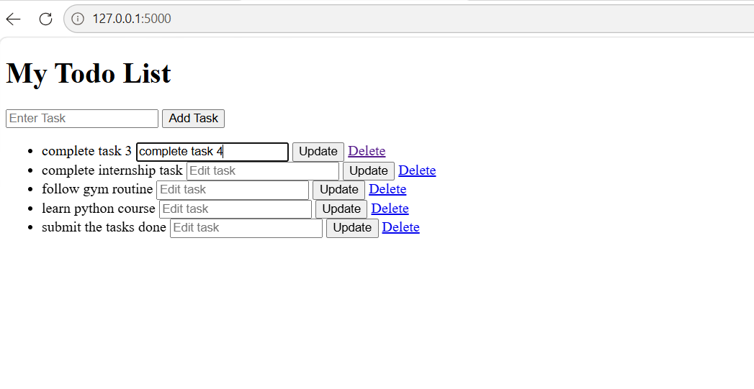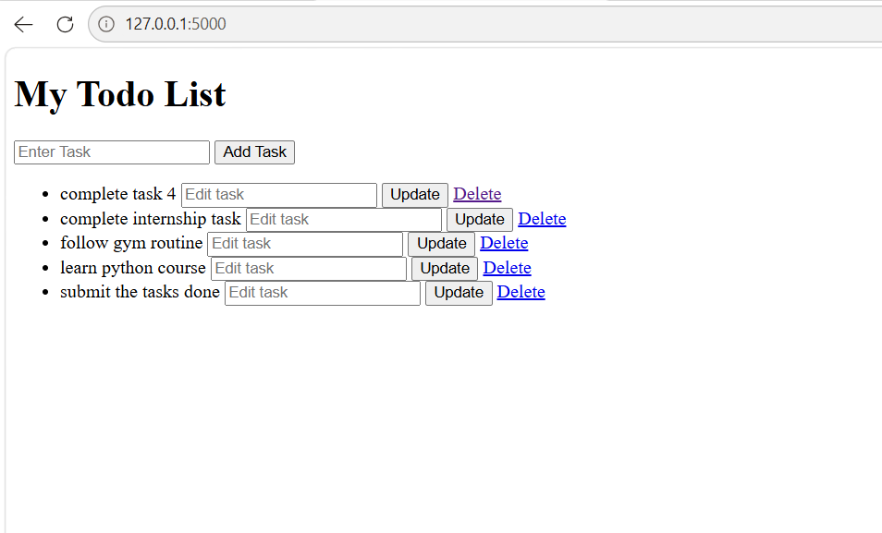

Delete Operation
A task is removed from the todo list.
Screenshot 8: Deleting a Task
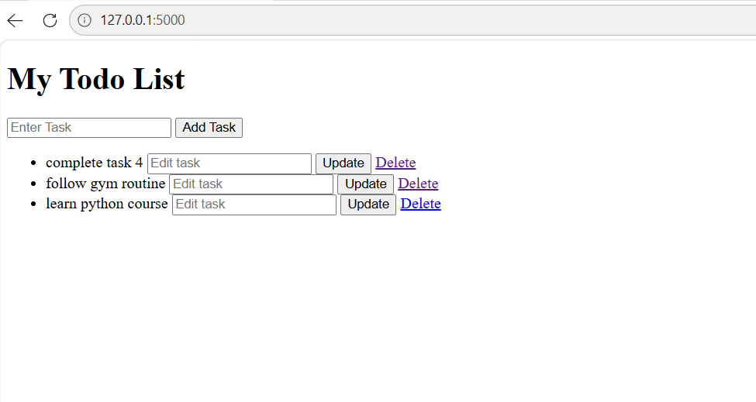
Output of cmd
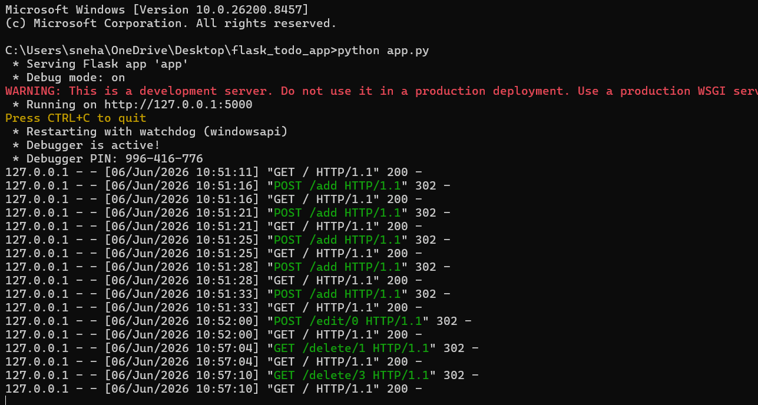

10. Result
The Flask Todo List Web Application was successfully developed and executed. The application performs all CRUD operations (Create, Read, Update, and Delete) effectively. The project demonstrates the use of Flask routing, templates, and web application development concepts.

11. Conclusion
This project helped in understanding the fundamentals of Flask web development, routing, template rendering, and CRUD operations. The Todo List application provides a practical implementation of a Flask-based web application and enhances knowledge of Python web development.
Outcome: Successfully completed Task 3 – Flask Mini Web Application using Flask.

